Testing Issues.

1. I cannot add a role to a user. See screenshots and replicate on your end  
     
   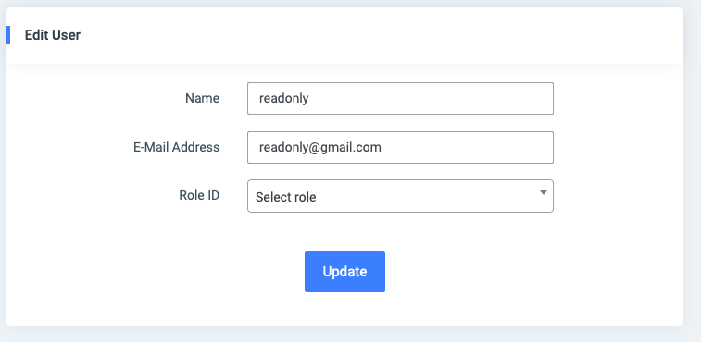

I then select a role to update: Consumer  
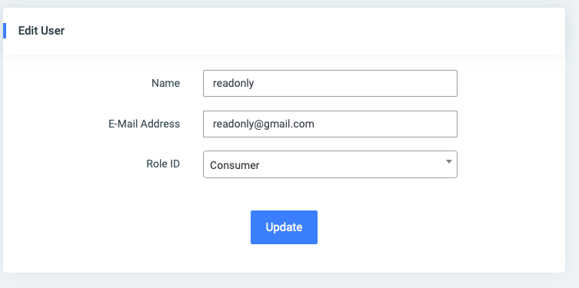

When I click on **Update,** the application crashes  
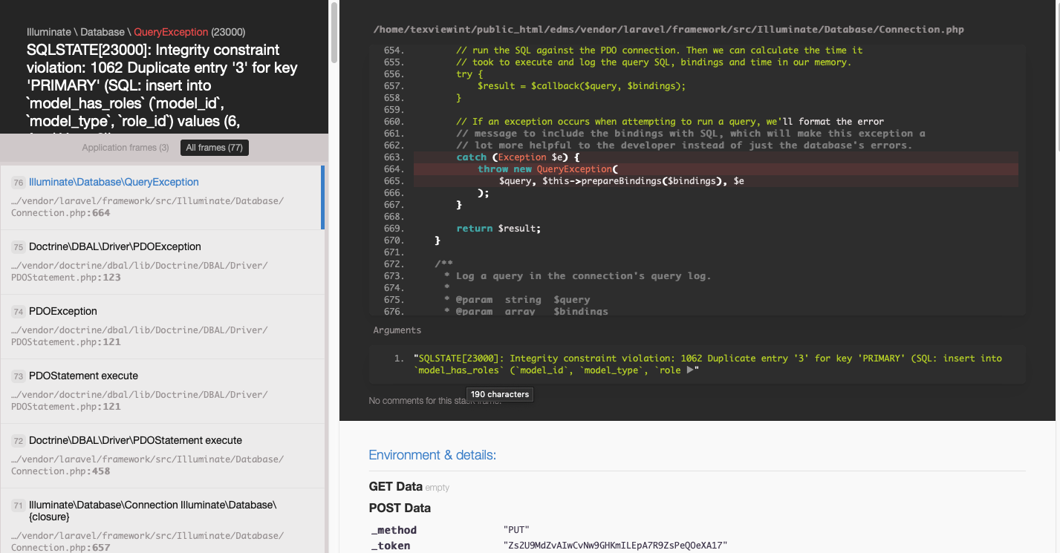

**DONE**

1. Modifications required in Edit Patient Screen  
     
   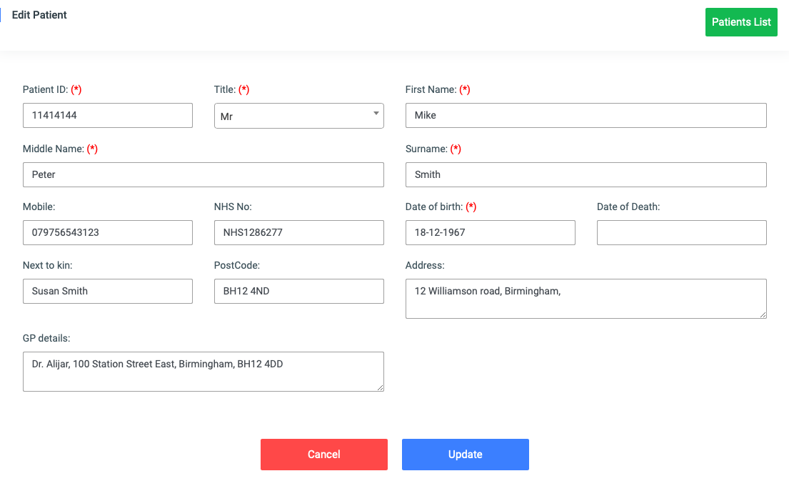

Middle Name is not mandatory  
 change ‘Next to kin’ to ‘Next Of Kin’

**DONE**

1. Previous versions not displaying the versions   
   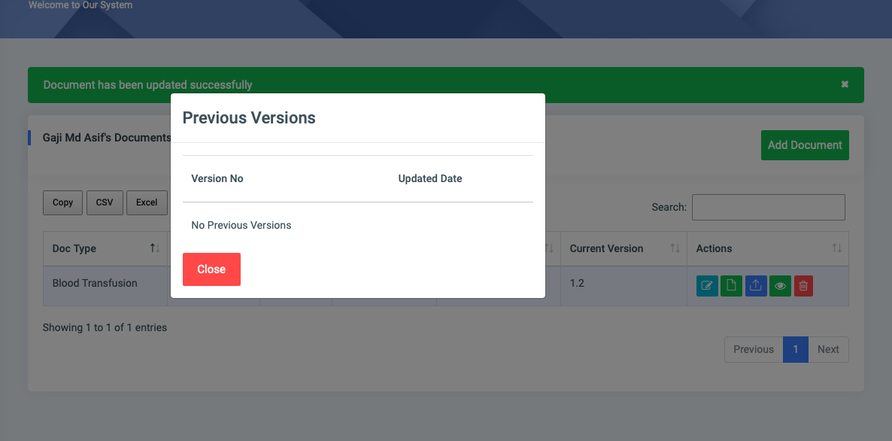  
     
   I updated the metadata of the above document. And when saved, the version changed from 1.1 to 1.2 as expected.  
   However, when I click on the previous version Action button, it does not display the previous version.

This is partially done. I can now see the different versions but cannot select the older versions to view. That is the reason for having different version.  
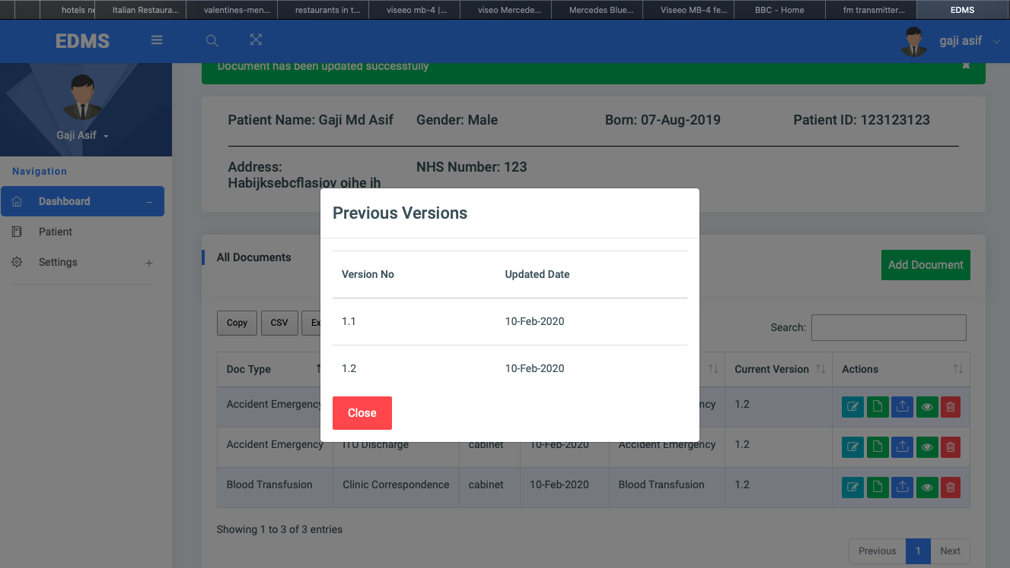

1. Can you please display the Patient details on the Document Screen

From this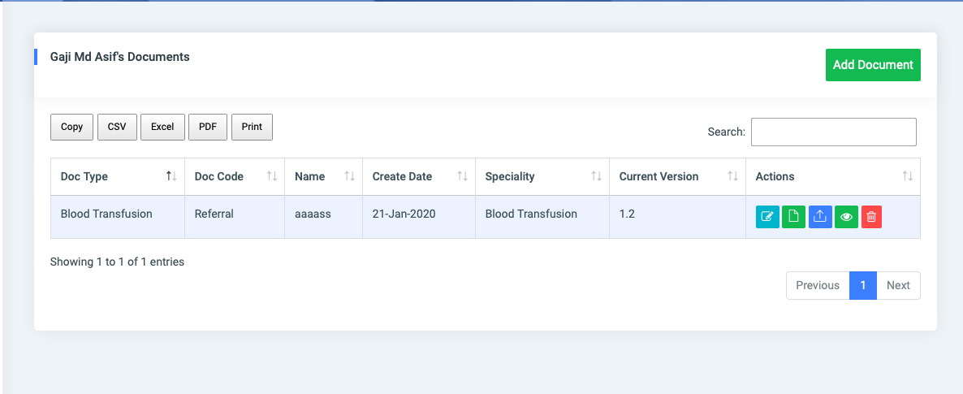

To this

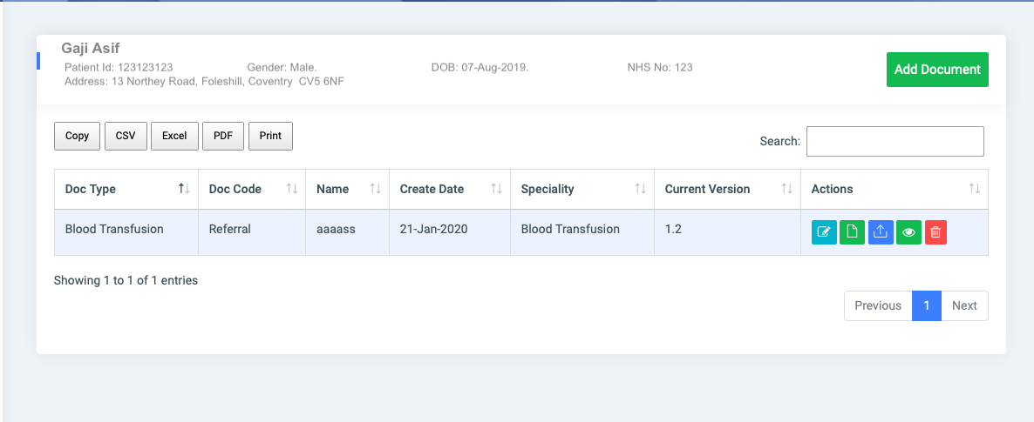

**DONE**

**NEW Issues found in this release today 10/02/2020**

1. I cannot add permissions to the roles and consequently cannot test the Consumer, Coordinator and Administrator roles.  
     
   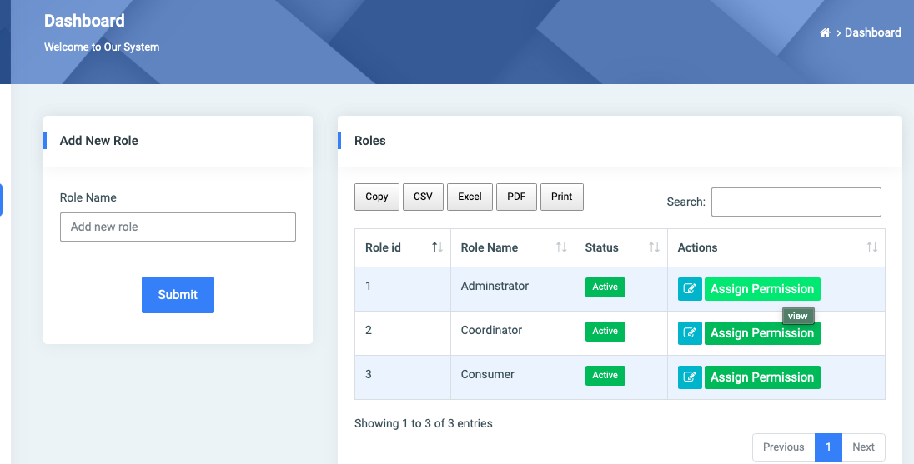  
     
   I get this below when I click on ‘Add Permission’ button above  
   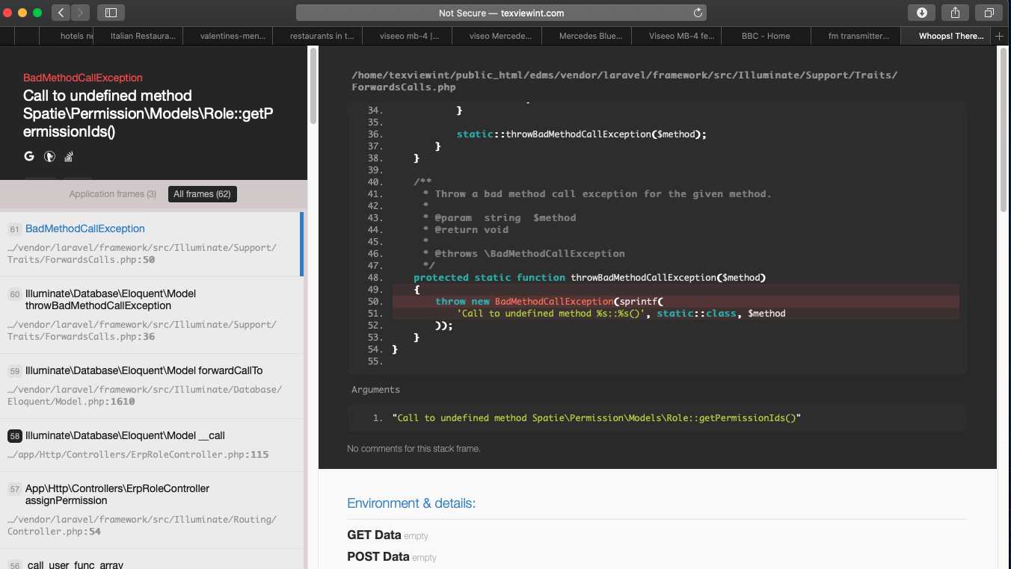
2. The Dashboard details showing the Audit events have disappeared.  
     
   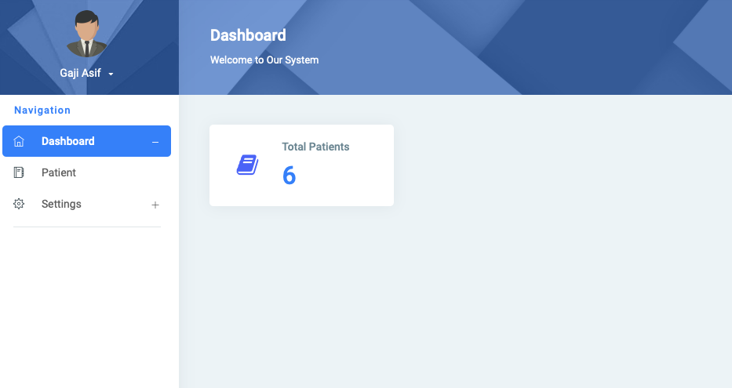
3. Checkin and Checkout are still missing from the application.

It is very important as when a document is checked out, the file is locked and others are prevented from editing the metadata or text of the document.

Checkin releases the document for editing by other users.